**Academic Year: 2025-26 Semester: V**

**Class / Branch: TEIT Subject: DevOps Lab**

**Name of Instructor: Ms. Sujata Oak**

# Experiment No. 4

**Aim: To install Jenkins and configure parallel jobs for building pipeline.**

**Theory:** Jenkins is an open-source automation server widely used in Continuous Integration (CI) and Continuous Delivery (CD) pipelines. It allows developers to automate building, testing, and deployment of applications. One powerful feature of Jenkins is the ability to execute parallel jobs in a pipeline, which reduces build time and improves efficiency.

**Objectives**

* Understand the process of installing Jenkins.
* Learn how to configure Jenkins for pipeline execution.
* Implement parallel stages in Jenkins pipelines to run tasks simultaneously.

**Continuous Delivery vs Continuous deployment**

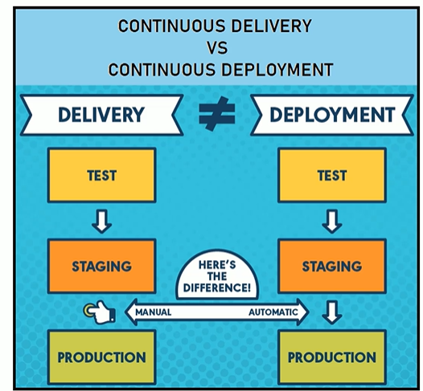

**Continuous Delivery** : The entire process is segregated into three phases:

Test, Staging and Production. The test and staging are automatic. But when you try to move your project from staging to production you need manual. So, this is called **continuous delivery.**

**Continuous Deployment:** All the phases test, staging and production is completely automatic.

There is no manual intervention is required. So, this is called **continuous deployment.**

**Implementation:**

**Create 3 jobs: Test , Staging and Production**

Test🡪Freestyle🡪Ok

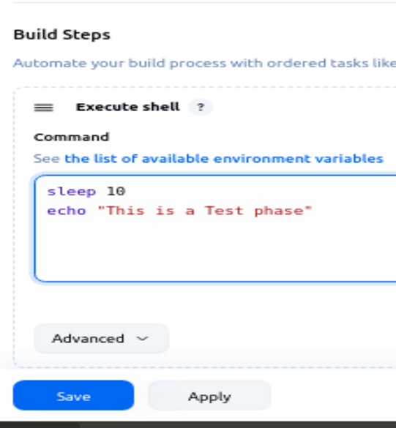

Staging🡪freestyle🡪Ok

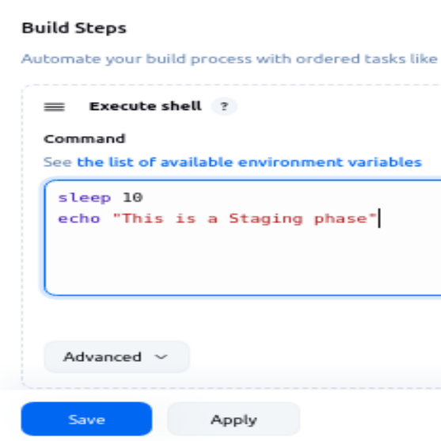

Production🡺freestyle🡪ok

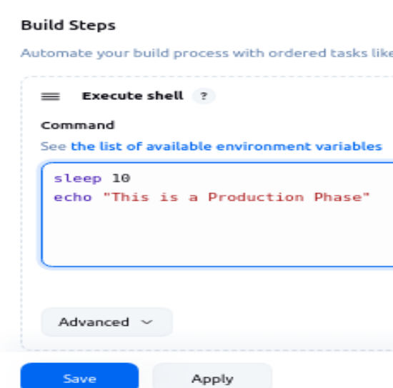

**Part I: Demo on concept of continuous delivery**

In continuous delivery you can see the test job and staging is continuous.

**Test🡪Configure🡪Add post build action🡪build other project**

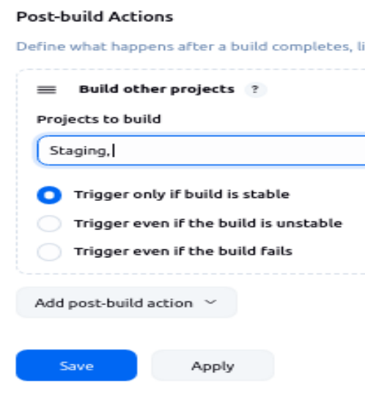

In Continuous delivery, test and staging would be automatic. But when you want to move from staging to production it should be manual.

Now goto staging job. In this staging job I have selected this option build other jobs manual step.

**Staging🡪Configure🡪Post-Build Actions 🡪 Build other projects (manual step)🡪production**

So I have created all my jobs and I have interlinked as per the continuous delivery.

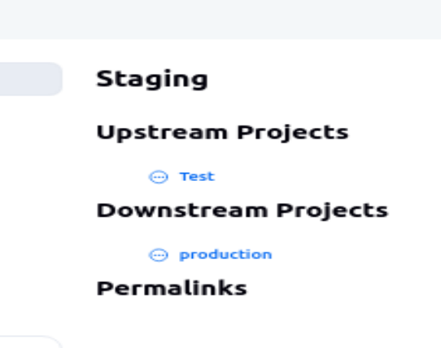

Goto Dashboard,

Now you need to click on this plus icon. New view: Name: continuous delivery.

And type: build pipeline view and click on create.

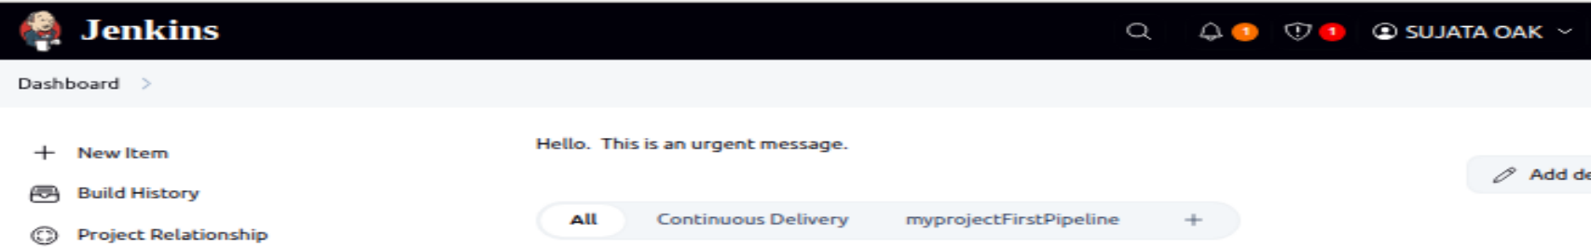



# 

and scroll down and look for your initial job.

My initial job is the test job.

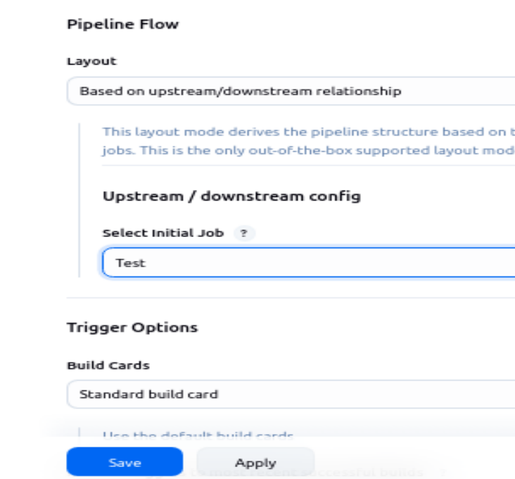

# 

# 

# 

Refresh it , still the production stage will not start Since it is a manual process in continuous delivery. We need to trigger it manually.

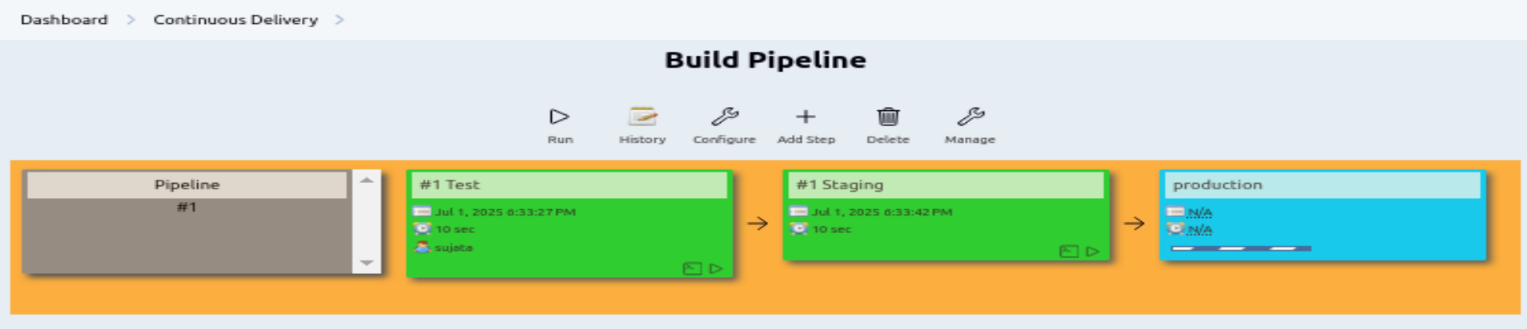

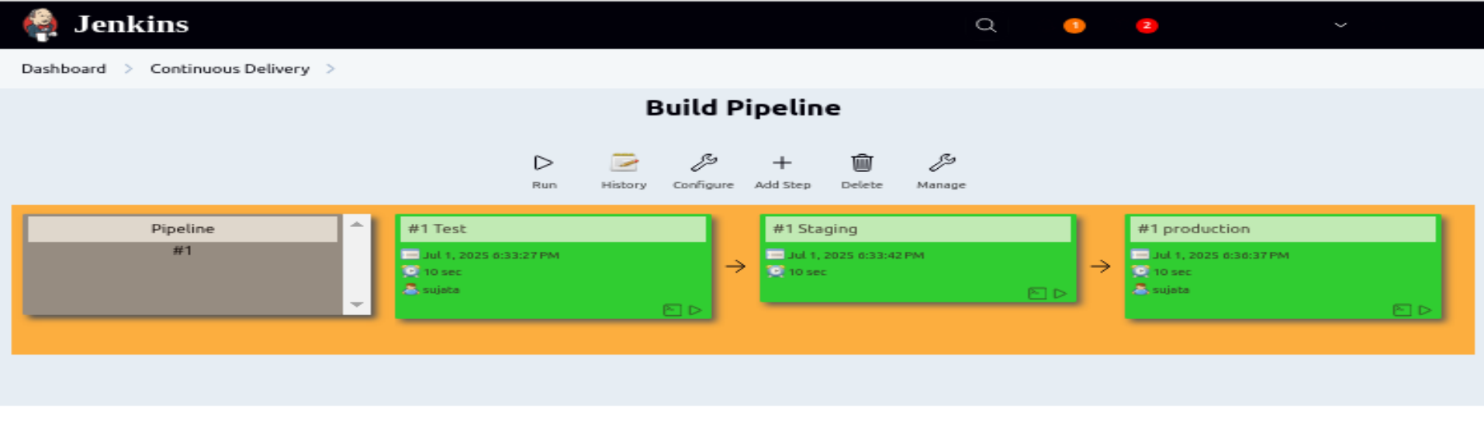

**Part II: Demo on concept of continuous deployment**

All 3 stages has to be automated

**Goto Dashboard🡪Staging🡪Configure**

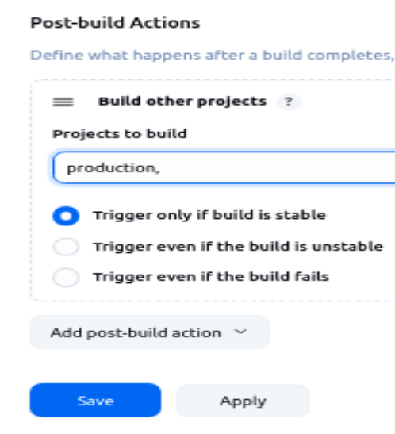

# 

**Part III: Parallel Jobs in Jenkins Build Pipeline**

In Test job🡪Configure

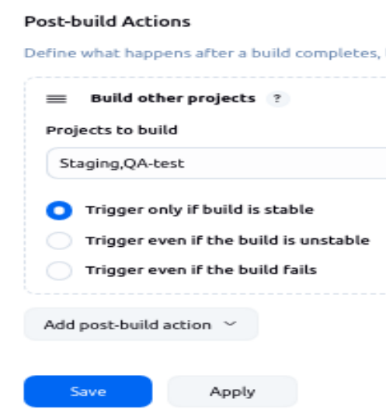

**Goto dashboard🡪 Click on Continuous Delivery**

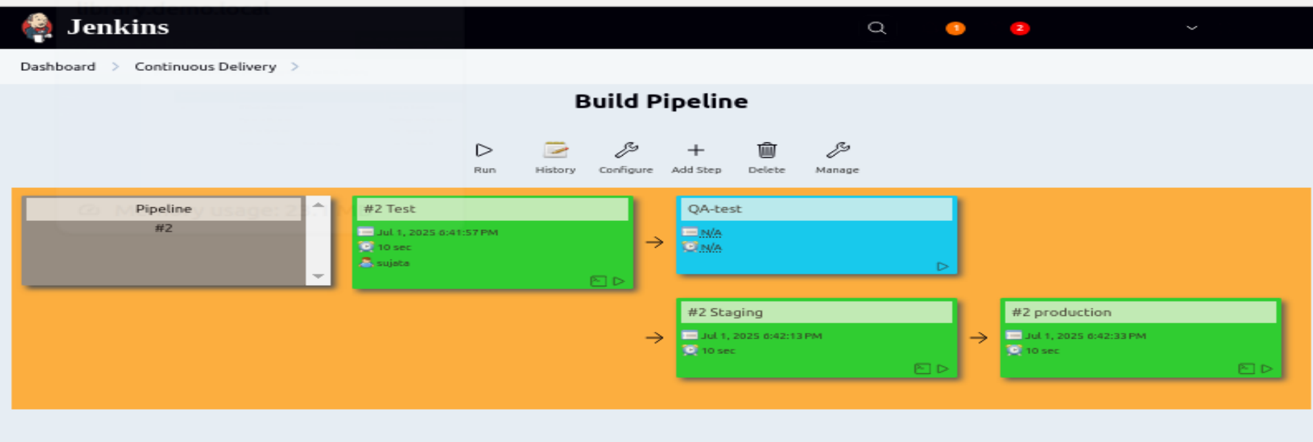

**Refresh and Run**

**1st job executed shown in green color**

**2nd job staging and QA-test will execute in parallel. Trigger the pipeline**

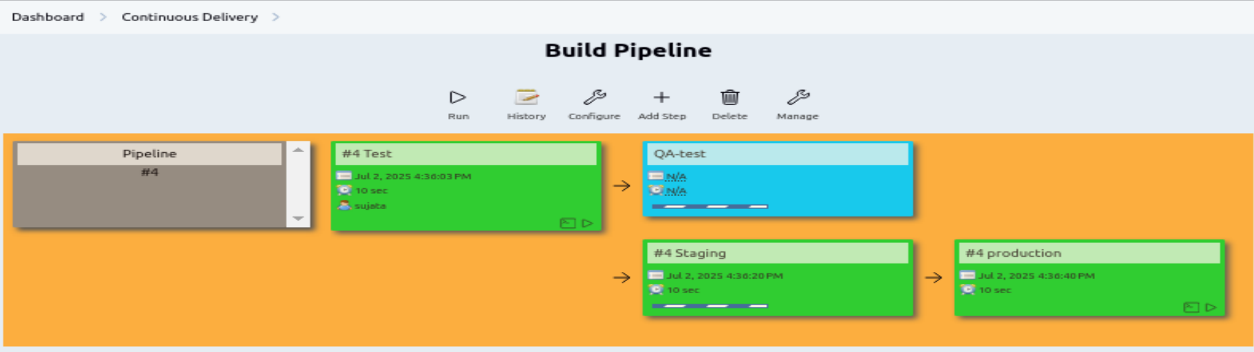

**At last all job will get executed and the color should be green.**

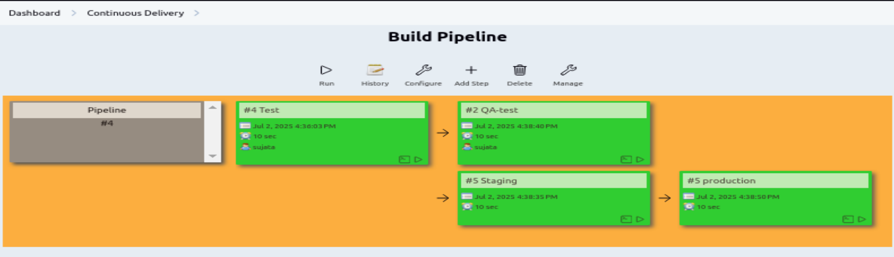

# Conclusion:

# In this experiment we successfully learned installing jenkins and setting up parallel jobs in a pipeline which significantly improves CI/CD efficiency. This approach helps in faster feedback cycles, quicker releases, and better utilization of resources. With proper pipeline configuration, teams can ensure high productivity while maintaining quality.